**Lab Report 08**

Problem

Using a heap data structure, create a program to handle and satisfy the conditions of the given driver file, which is to schedule food orders.

Solution Description

By creating an Order class file, I populated a heap of pending orders to reference when the current order is done cooking. The OrderScheduler class handles methods needed to carry out these operations and ensure the orders are correctly scheduled.

Problems Encountered

I ran into a run-time error when advancing to the next order because the current order was not changed accordingly in the program. To remedy this, I set the current order to null before adding the next one to be cooked from the heap.

4. O(n2)

5. O(n(lgn))

6.

7.

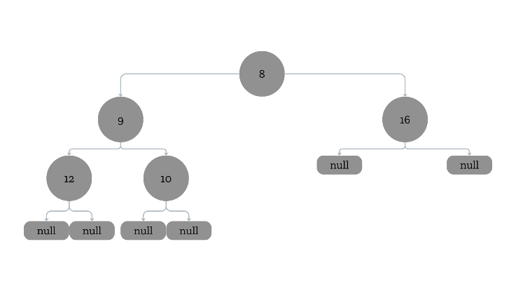

8. Double the current index value and increment it by 1.

9. Double the current index value and add 2 to it

10. Subtract the current index value by one and then divide it by half.